**Soap ui**

**Task**

1)Create new project

Create Test suit

Create test cases for each operation Add, Divide, Multiply, Subtract

Add Assertions for test cases

Run test suit

Add

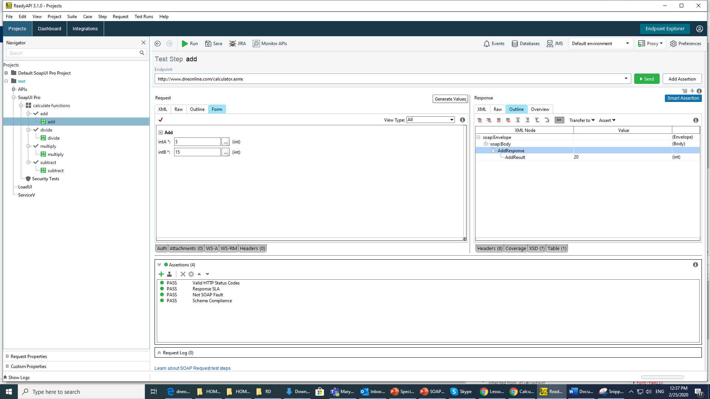

Divide

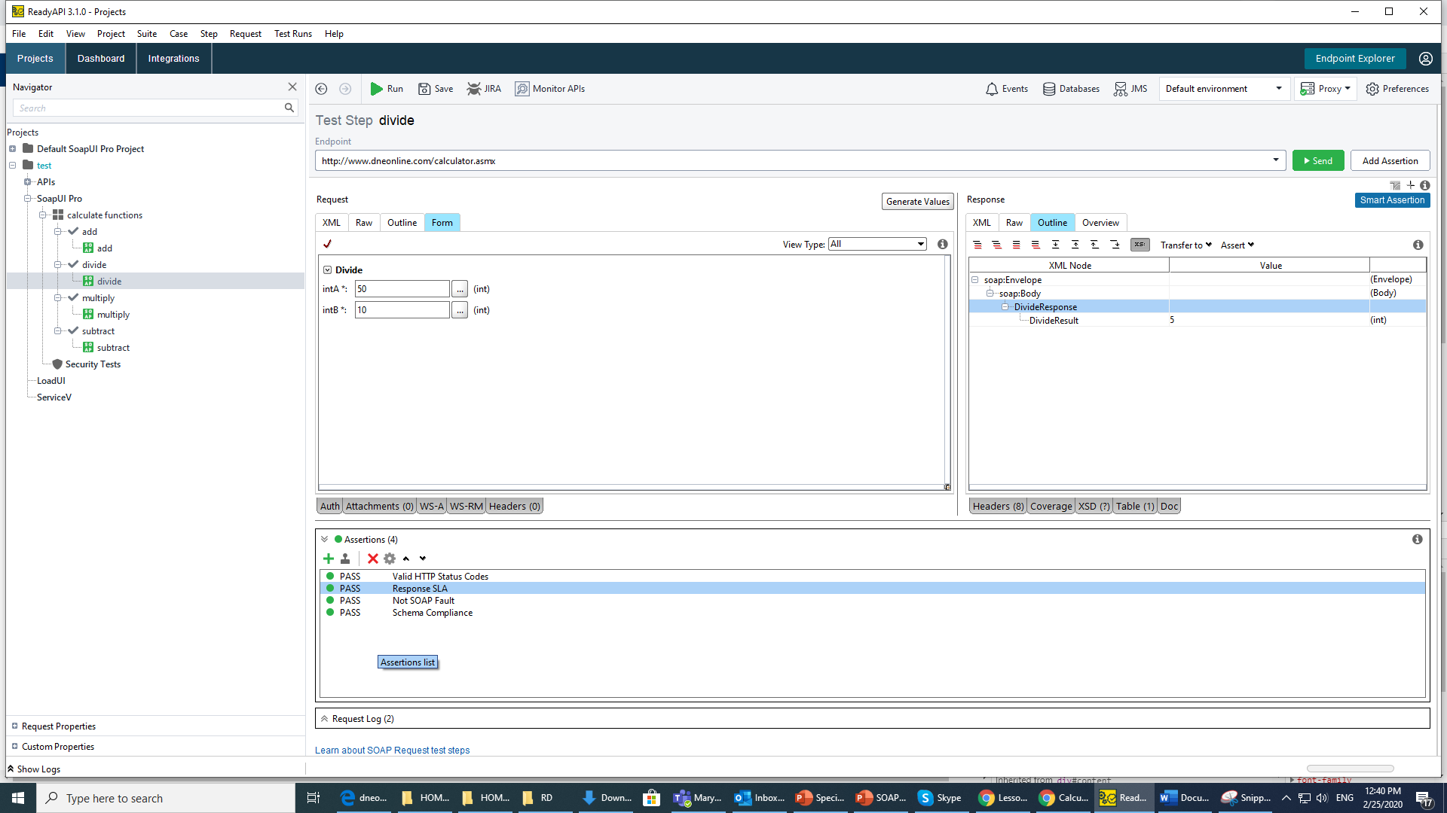

Multiply

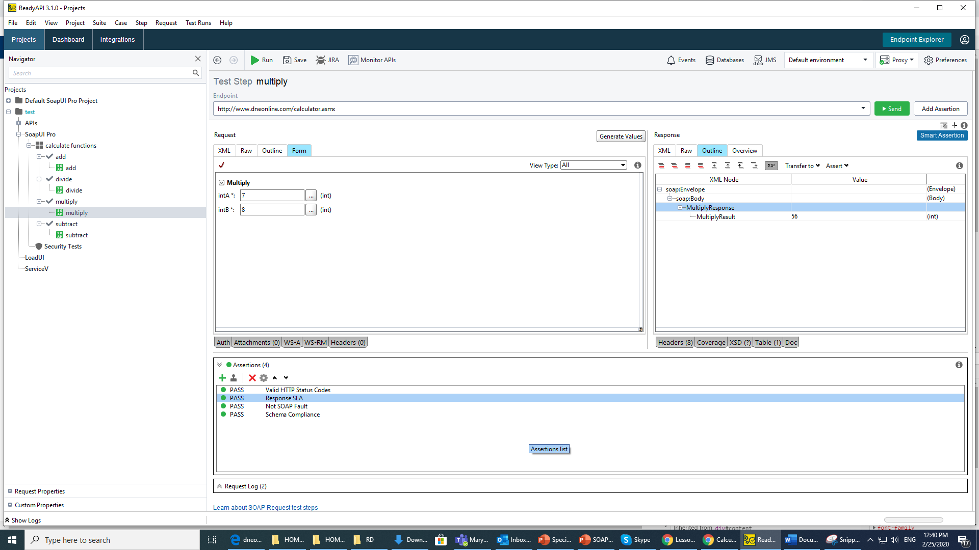

Subtract

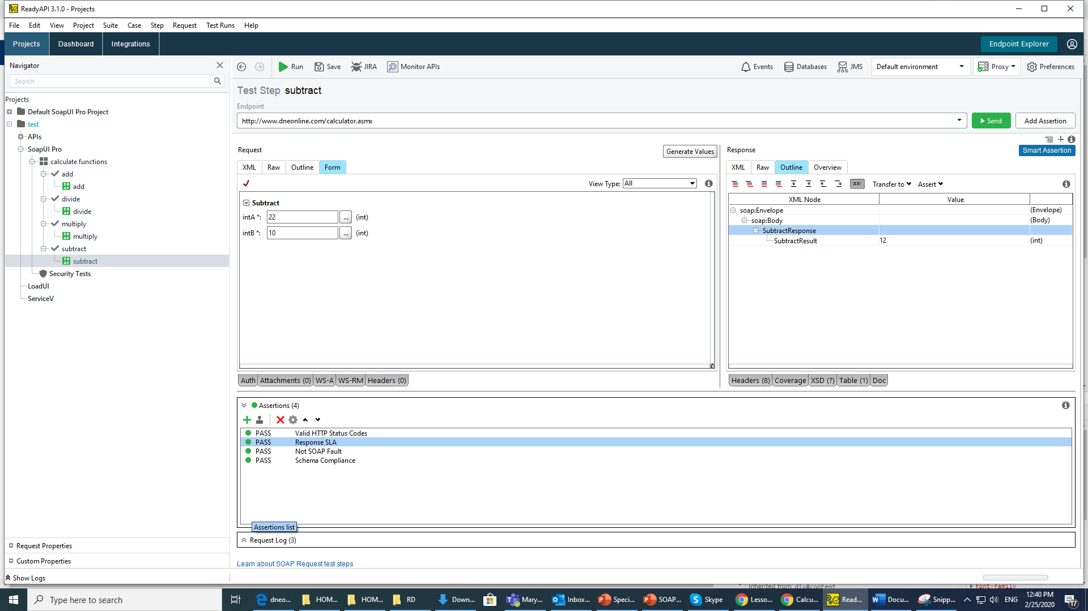

Run test suit

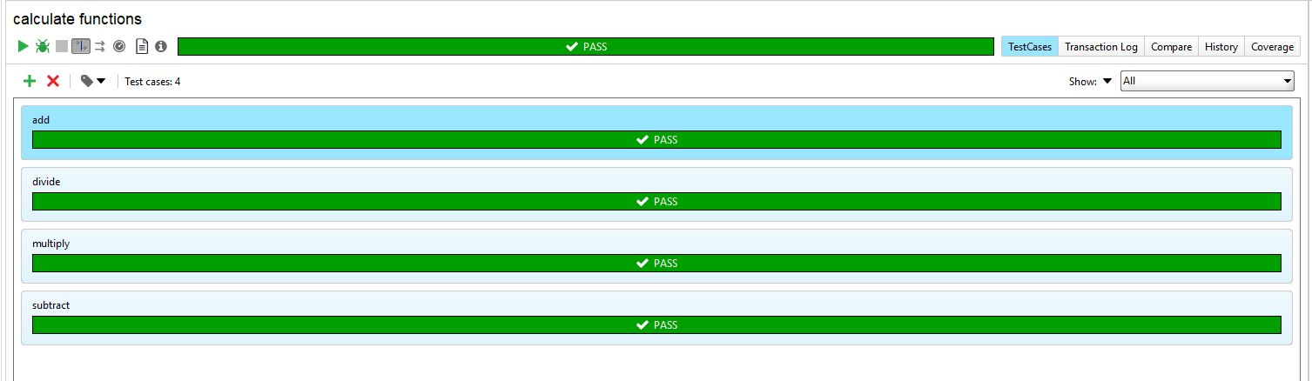

2) Create REST Project

Test server [http://petstore.swagger.io](http://petstore.swagger.io/)

Create Test Suit

Create 2 test cases for each request (GET, POST, PUT, DELETE)

Run Test Suit

Get id=1

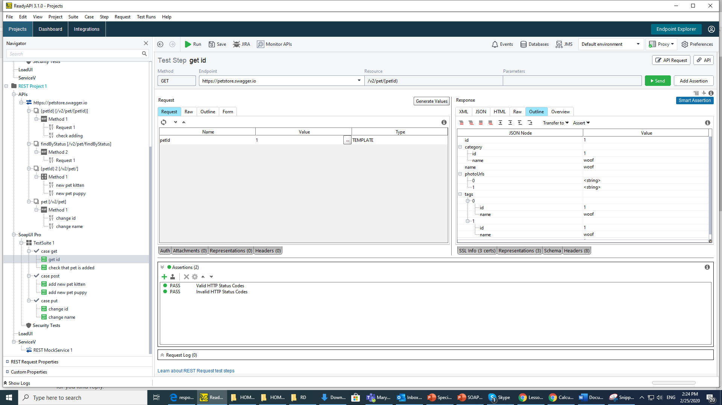

Get id=28 ( check that pet is added by POST)

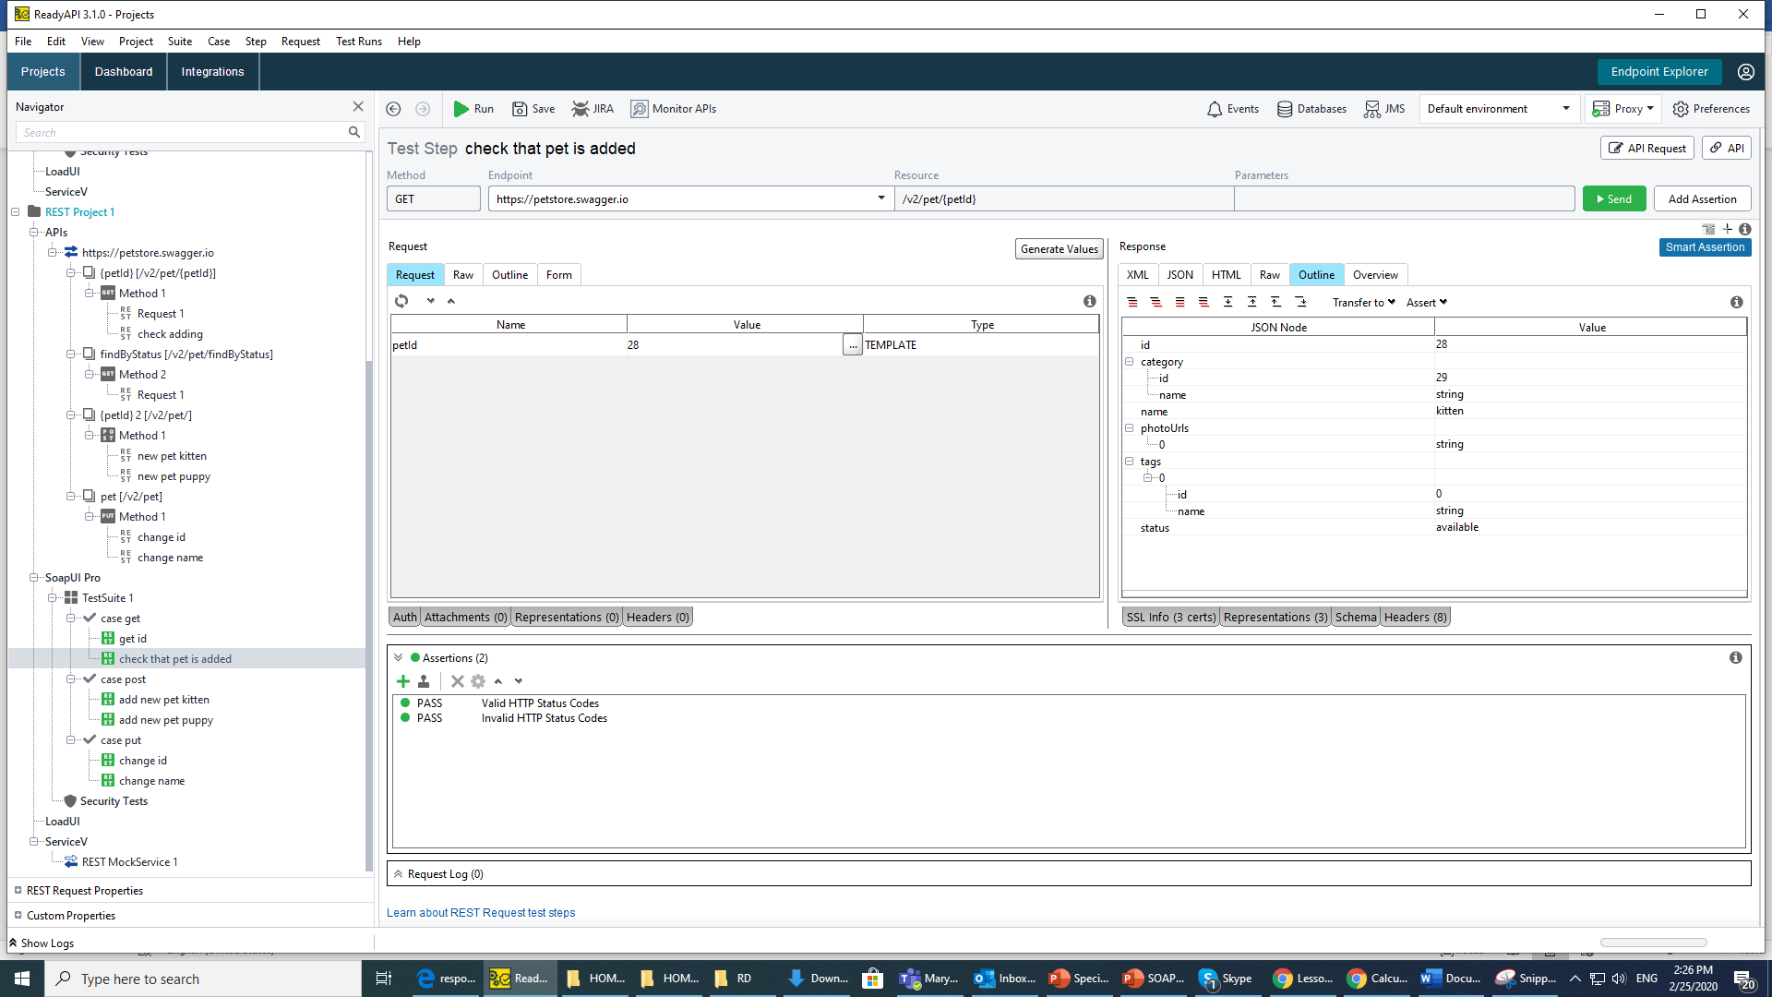

Post new pet 1

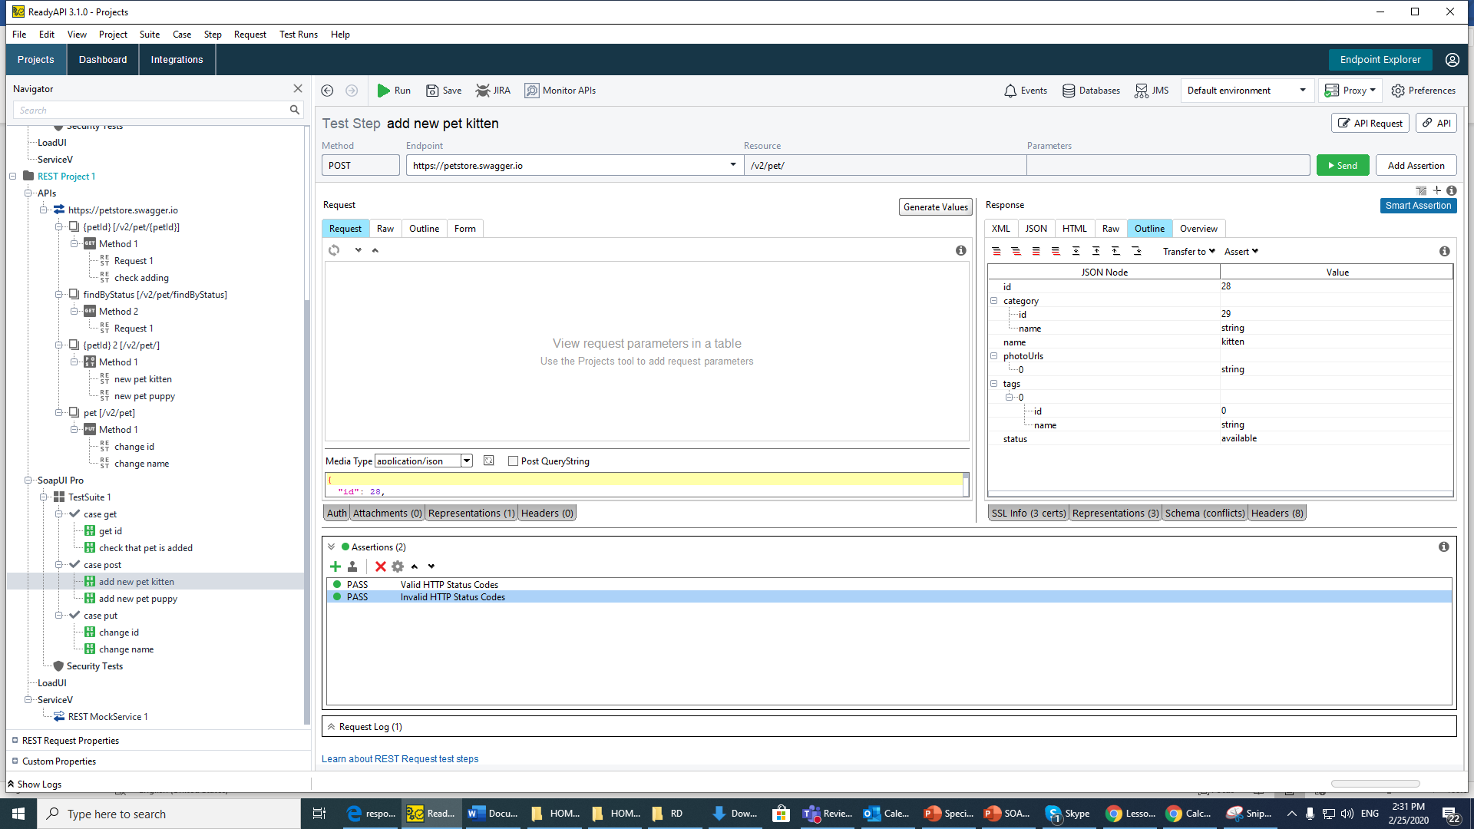

Post new pet 2

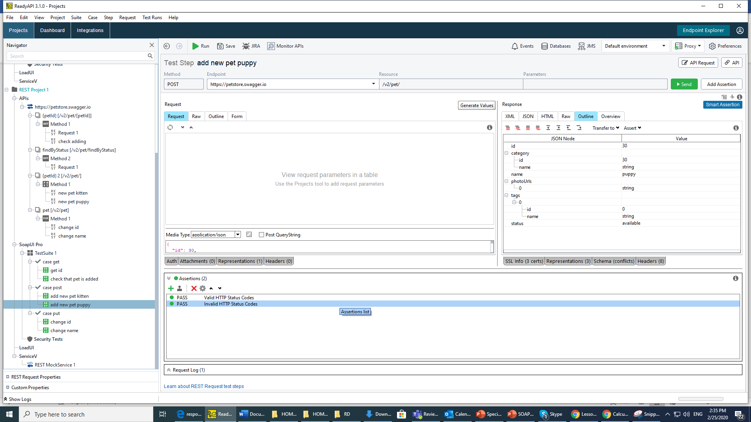

Put (Change id pet)

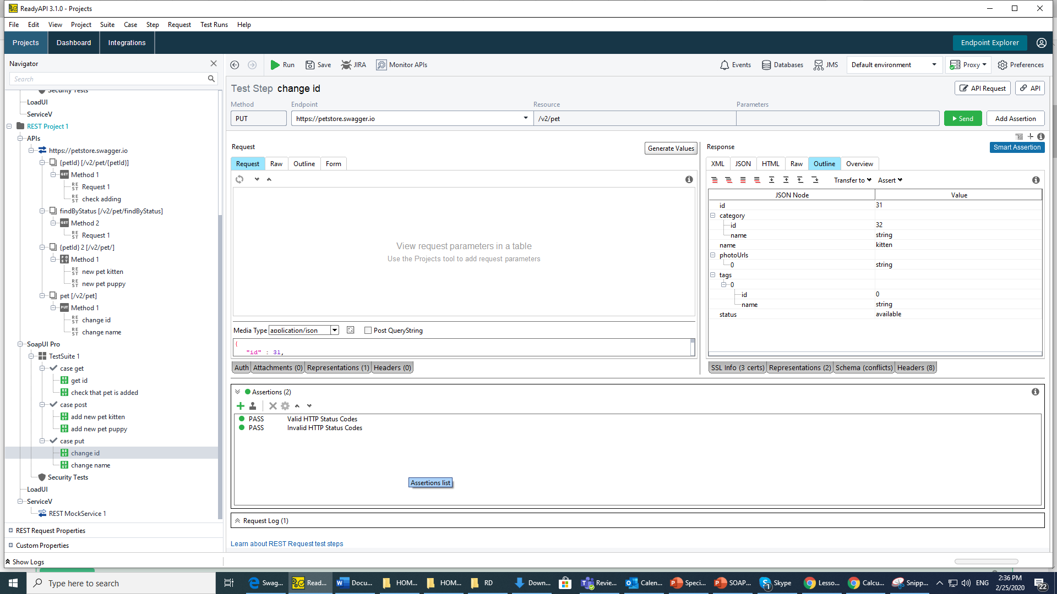

Put (Change name pet)

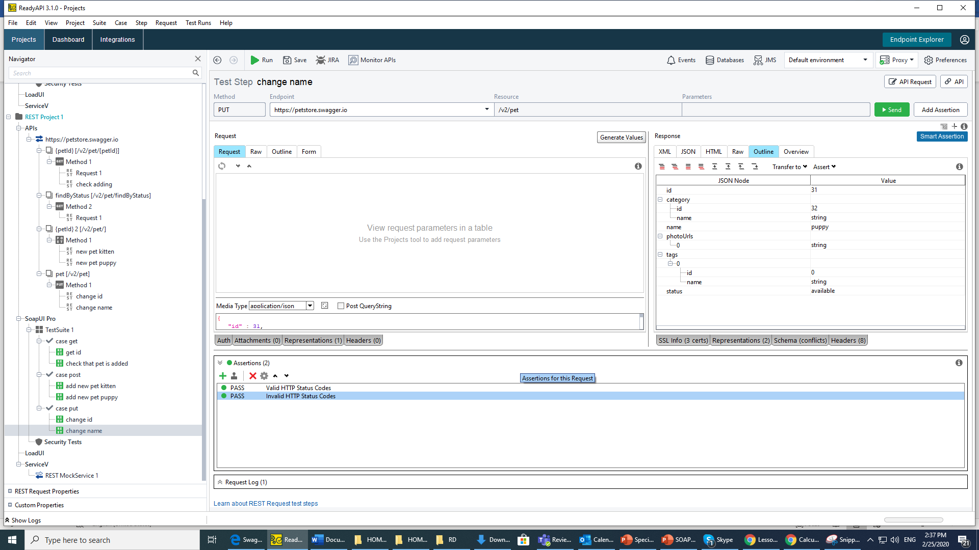

Delete by id 1

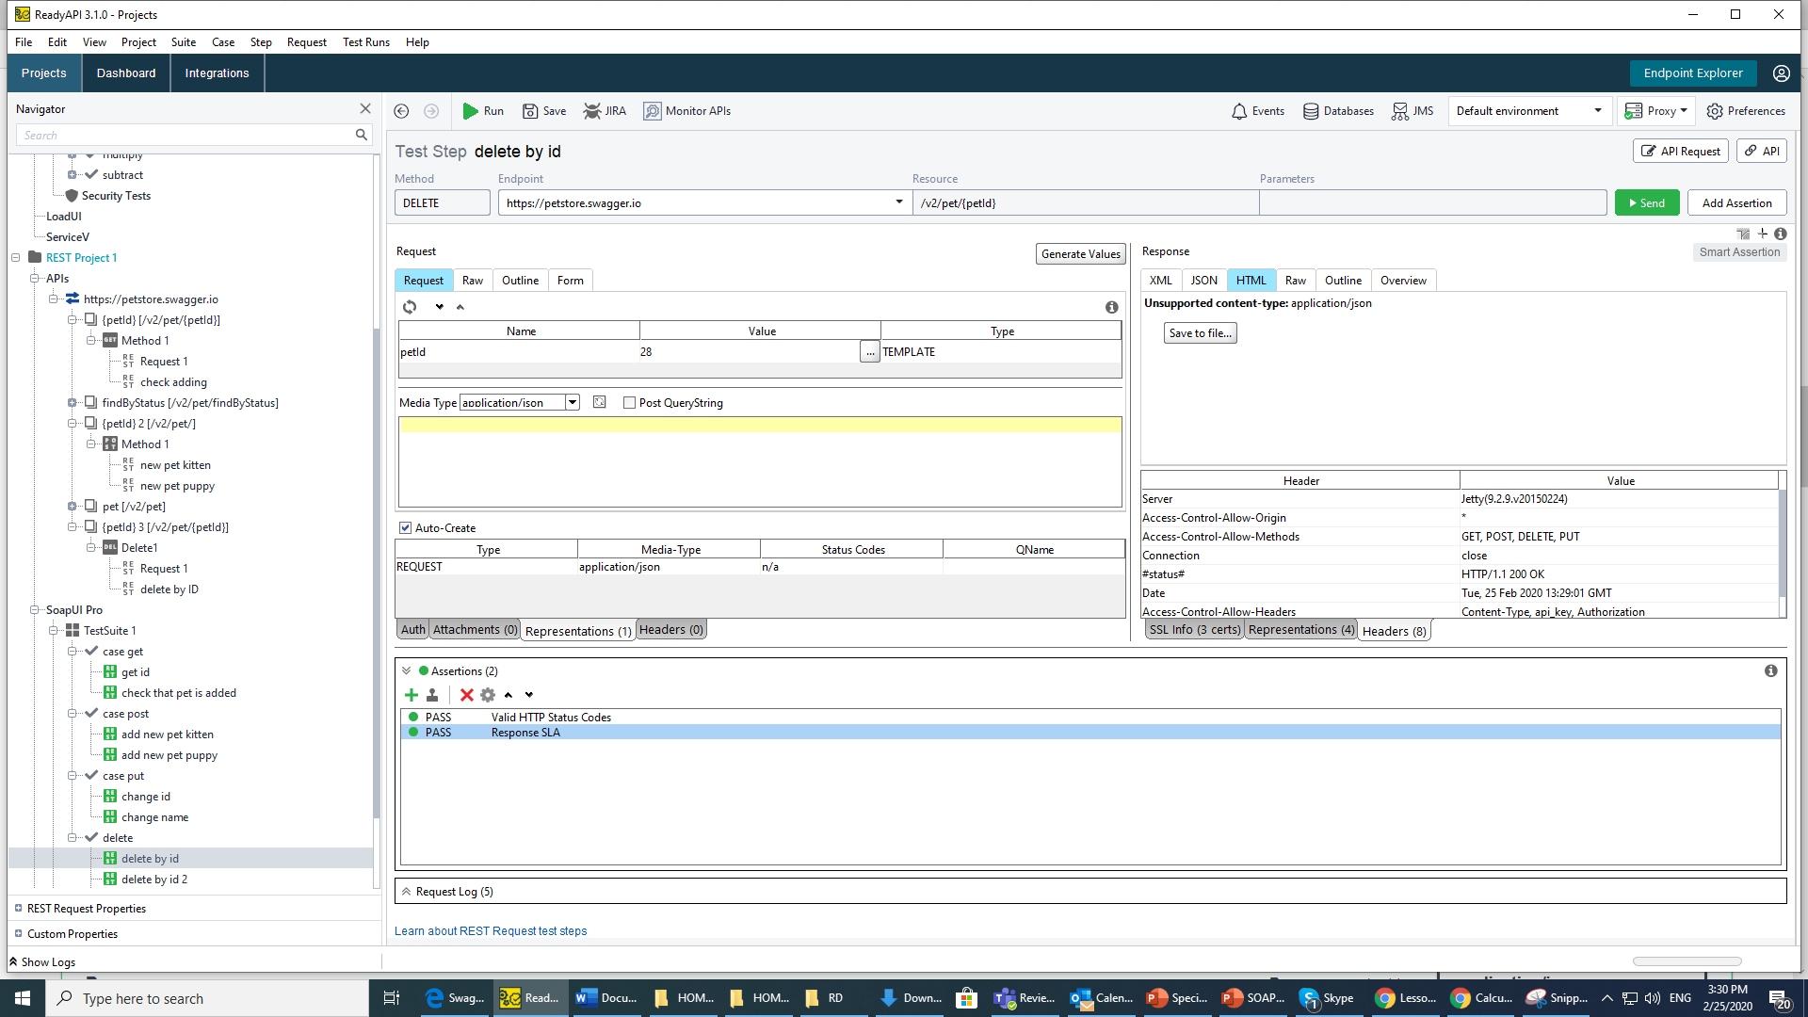

Delete by id 2

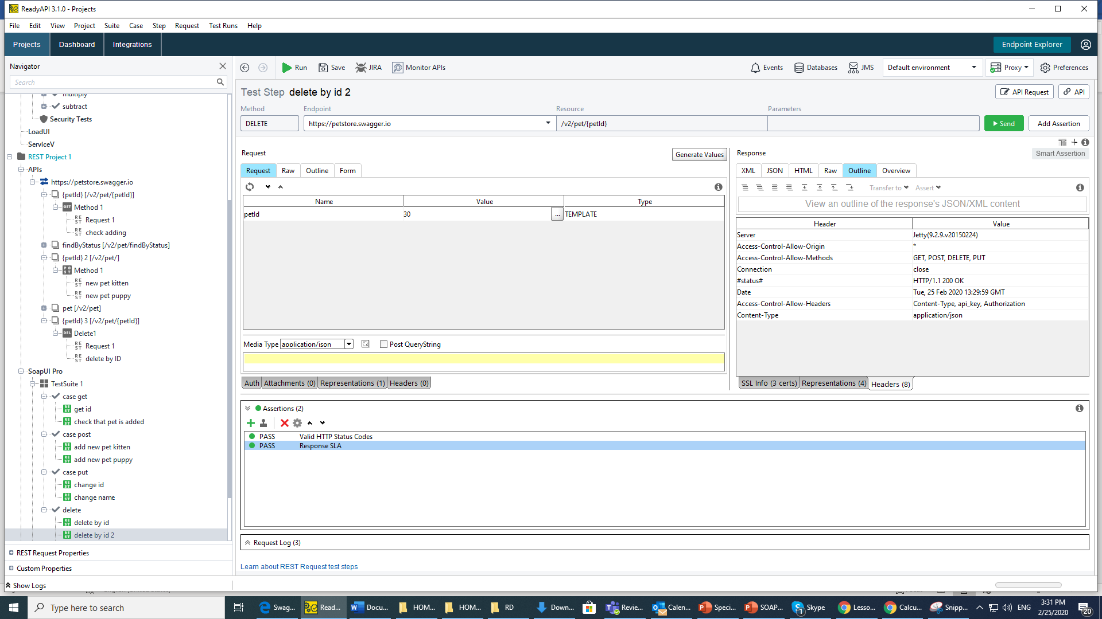

Run test suit

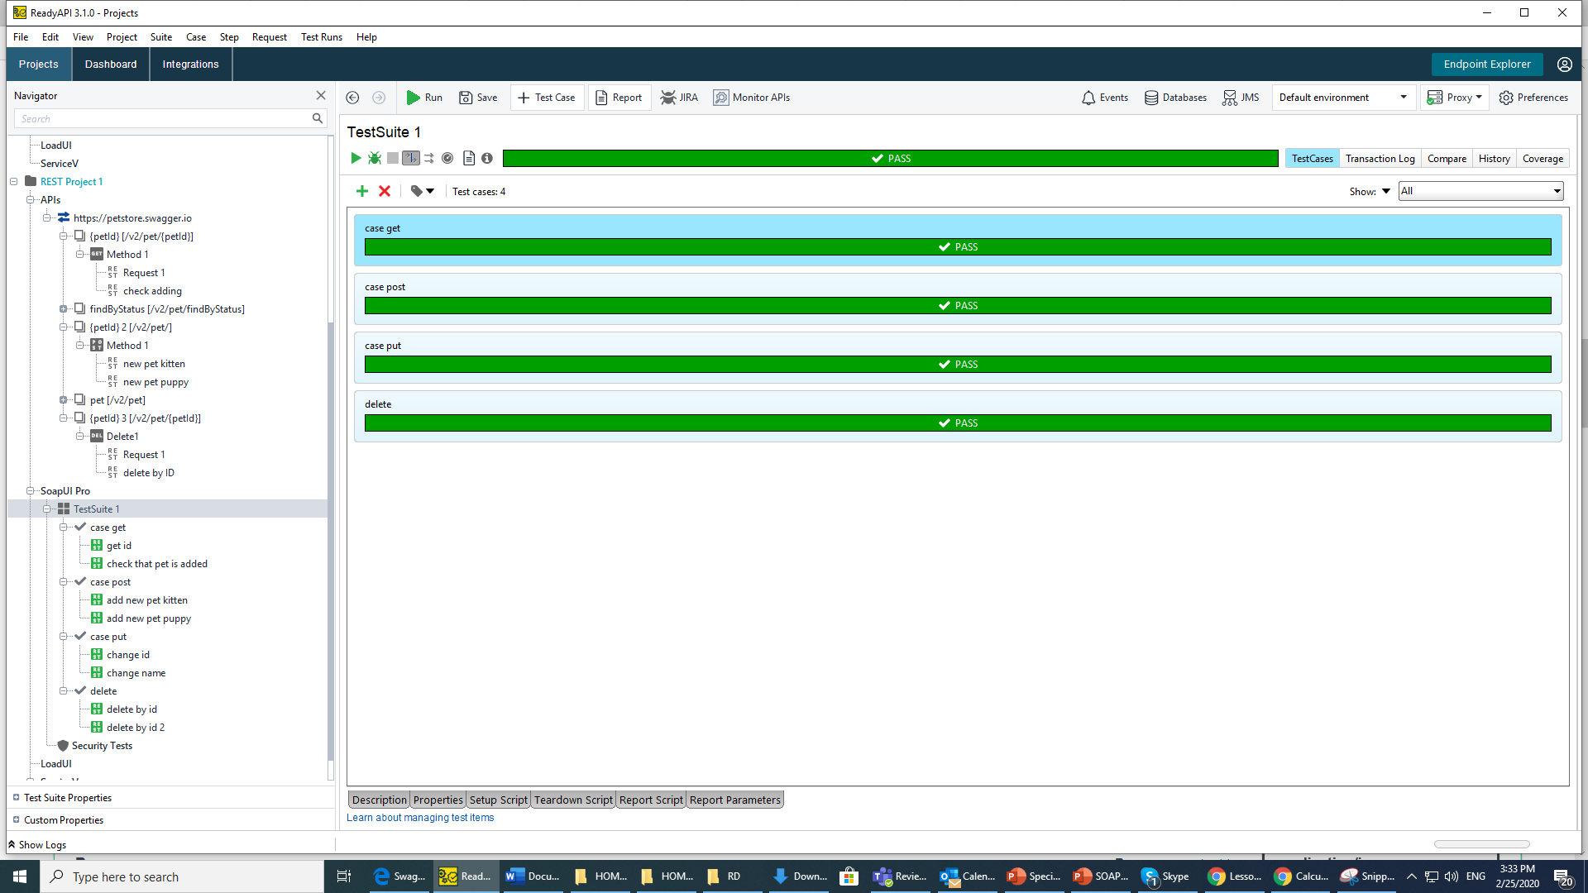

3) Create and test Mock service

